The HARMONIE-AROME model was first introduced into operations in Met Éireann in 2011. As research progresses, new versions of the model code (known as cycles) are developed. These allow us to upgrade our operational system. In 2024 this model underwent an upgrade introducing significant improvements.
Historical NWP data configuration is given below.
Our previous operational NWP, know as IREPS (Irish Regional Ensemble Prediction System), was configured of 1000 x 900 grid points in the horizontal at 2.5 km resolution, with 65 levels in the vertical. A 54-hour forecast is produced eight times a day, beginning every three hours from 00Z.
Current NWP model.
A press release covering the background and the collaborations associated with our new operational model, DINI and DINI-EPS (Denmark, Iceland, Netherlands, Ireland – Ensemble Prediction System) can be found on our website
Model differences: IREPS vs DINI-EPS
 | IREPS (Previous model) | DINI-EPS (Current model)
Harmonie-Arome code version | 43h2.1 | 43h2.2.1
Horizontal grid | 2.5km | 2.0km
Vertical levels | 65 | 90
Cycling frequency | 3-hourly | Hourly
Forecast length | T+54 | Control T+60  EPS members T+54
Lowest Level | 12m | 5m
Number of EPS members | 1+15 | 1+30

EPS members

Forecast Runtime​ | Member 0​ | Members 1-5​ | Members 6-10​ | Members 11-15​ | Members 16-20​ | Members 21-25​ | Members 26-30​ | 06Z Continuous​ | IFS ENS LBCs Used​
01Z​ | +60h​ | --​ | +60h​ | --​ | --​ | --​ | --​ | Use ​  T+5 to T+59​ | 18Z​
02Z​ | +60h​ | --​ | --​ | +60h​ | --​ | --​ | --​ | Use ​  T+4 to T+58​ | 18Z​
03Z​ | +60h​ | --​ | --​ | --​ | +60h​ | --​ | --​ | Use ​  T+3 to T+57​ | 18Z​
04Z​ | +60h​ | --​ | --​ | --​ | --​ | +60h​ | --​ | Use ​  T+2 to T+56​ | 18Z​
05Z​ | +60h​ | --​ | --​ | --​ | --​ | --​ | +60h​ | Use ​  T+1 to T+55​ | 18Z​
06Z​ | +60h​ | +60h​ | --​ | --​ | --​ | --​ | --​ | Use ​  T0 to T+54​ | 18Z​
07Z​ | +60h​ | --​ | +60h​ | --​ | --​ | --​ | --​ | Use ​  T+5 to T+59​ | 00Z​

EPS members 1 + 5 each hour, members 1+30 over a 6 hour period. Users will need to lag the members to form a valid 1+30 ensemble.

Meteorological improvements.
The main meteorological improvements in moving to the DINI-EPS model are the following:
- Improved treatment of low cloud providing improvements in visibility forecasts.
- 10m wind speeds are significantly improved due to better representation of the boundary layer. Most of the extra model layers near the surface.
- Better estimates of Night-time temperatures.
- (Summer) day-time maximum temperatures slightly cooler
- Thin snow melt better represented.
- Captures more turbulence and boundary layer processes.
- Better representation of graupel in the microphysics and a subsequent improve representation of Lightning. This is a diagnostic tool.
- Larger domain to the south and southwest. Capturing weather events such as heat plumes travelling north from the Bay of Biscay.

Technical details.
The data from DINI-EPS will be made available in grib2. The grib2 data will be packed using the ccsds packing technique, as recommended by the World Meteorological Organisation (WMO) and as is currently done for IREPS data.
NWP files are in grib2 format. A comprehensive overview of the grib2 format can be found here

Geographic domain
A comparison of previous domain versus the current model domain (in blue) is given in the graphic below.
IREPS (previous) | DINI-EPSv(current)

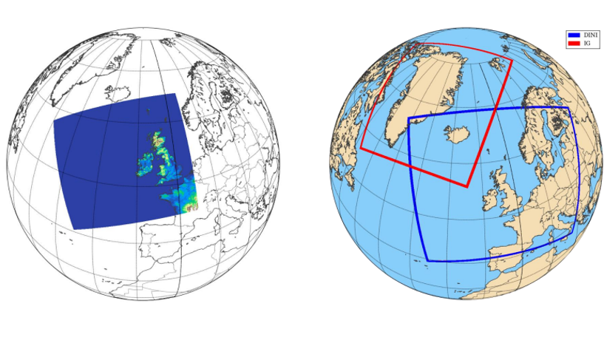
The DINI model uses the Lambert Conformal conic projection.

